ARM Notes from the field story

Title: Learning New Tools and Giving Back, ARM at Scipy2017

ARM developers, translators, and engineers from three laboratories attended the Scientific Computing with Python (Scipy, [1]) conference in Austin Texas in July of 2017. Scipy is a unique conference focused on scientific applications of the programming language Python. The conference is organized into three components. The first two days are tutorials [2] followed by 3 days of conference talks [3]. What makes SciPy unique is the the final two day code sprint where attendees collaborate together to improve the state of open source packages live at the conference [4]. This code sprint not only improves the open source packages, but gives attendees a chance to learn from experienced software developers.

A unique aspect of Scipy is that it is focuses on the tools that are used across diverse domains. There is a focus on the "how" over the "what". The main benefit to the ARM program is attendees come away with a quiver of new tools saving many hours of coding and research.

Developers and engineers from across the ARM program attended tutorials at the beginning of the week. They were led by expert instructors (often core code developers) on Machine Learning, visualization, code optimization and project Jupyter (an interactive notebook environment and tool for scientific reproducibility).

The Conference proper kicked off Wednesday with Keynote sessions and poster sessions. Precipitation Radar Translator and Py-ART lead Scott Collis presented a poster on ARM's radar retrieval efforts. Bobby Jackson and Mark Picel, also from Argonne, showed some recent results from CMDV funded work on multi-Doppler vertical velocity retrievals and storm cell tracking.

On Friday Joseph Hardin, from Pacific Northwest National Lab and ARM radar engineer gave a well received talk on WARNO: Watchdog for ARM Radar Network Operations demonstrating how Python tools were being used to track the health of the ARM radar network.

Bhargavi Krishna from Oakridge National Laboratory and Erol Cromwell and Carina Lansing from Pacific Northwest National Laboratory Gökhan Sever, a numerical modeller from Argonne also attended to learn the latest tools in the Scipy stack which will help them better deliver data to ARM users.

Saturday and Sunday was set aside for code sprinting where diverse (by funding and field) scientists get together in large groups and collaboratively work through issues in popular community software packages. Bobby and Zach sprinted on the three dimensional visualization package yt [5], where the team was very interested in using yt to visualize ARM radar data. Mark sprinted on Pandas [6] which is a high performance data analysis library.

ARM Team members use open source software every working day. Scipy sprints allow us to give back to the community tools that make our work possible and learn from very clever developers along the way!

[1] https://scipy2017.scipy.org

[2] https://scipy2017.scipy.org/ehome/220975/493418/

[3] https://scipy2017.scipy.org/ehome/220975/493422/

[4] https://scipy2017.scipy.org/ehome/220975/493419/

[5] http://yt-project.org/

[6] [http://pandas.pydata.org/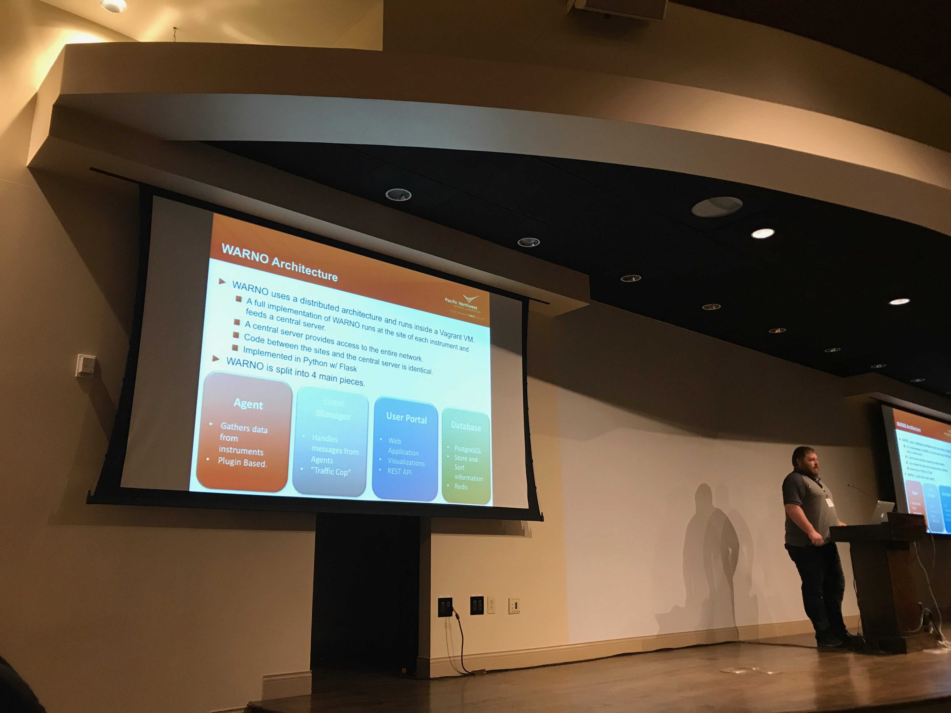](http://pa##ndas.pydata.org/)

Joseph Hardin, Radar Engineer from PNNL presents on ARM's WARNO architecture at Scipy2017.

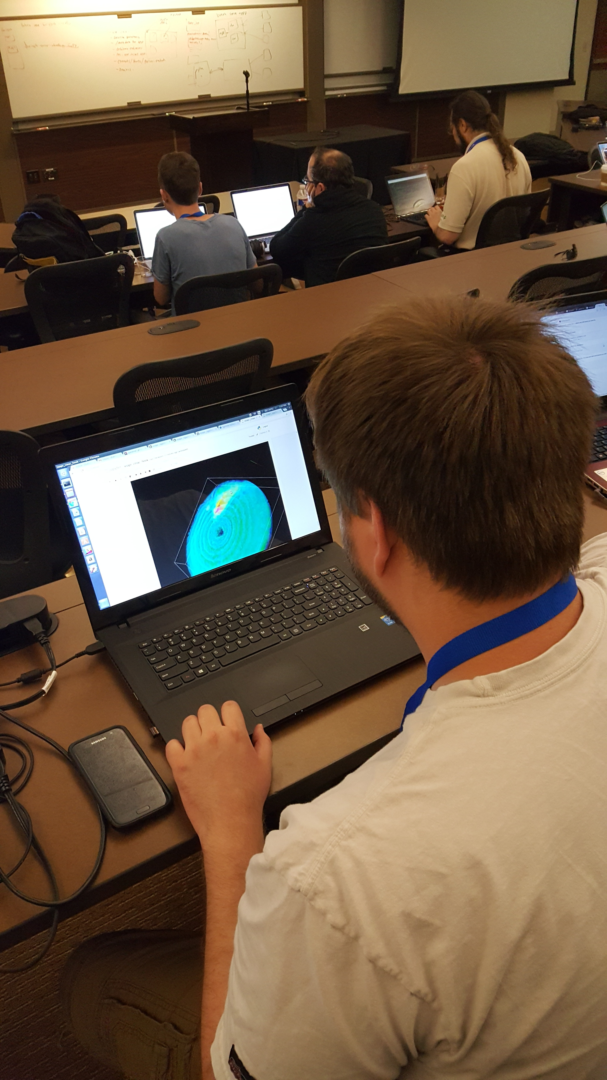

Zach Sherman, Software Developer from Argonne National Laboratory, sprints on the yt visualization package at Scipy2017.